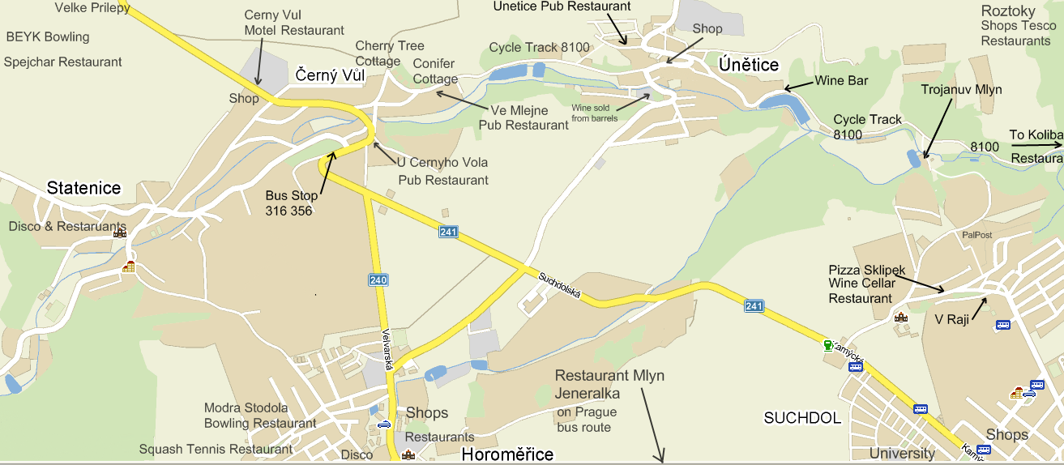

Špejchar Restaurant – excellent “Old Hay Barn” restaurant Kladenská 18 Velké Přílepy 11:00 - 01:00 +420220930183
www,BEYK.cz Bowling Kladenská 18 Velké Přílepy 15:00 – 01:00 +420220930489

www.Detaillo.cz – excellent
Easy walk towards Statenice
Rent-a-Chef +420724076655
www.Bowling-ModraStodola.cz Spojovací ul Horoměřice
11:00 – 03:00 +420220970344
Squash Horoměřice 220971815
www.MotoRestCernyVul.o1.cz reliable Motel Restaurant menu 10:30 – 21:00 +420220970295
U Černýho Vola Pub Restaurant Hot pub snacks always available.
Ve Mlejne Pub Restaurant
Family pub with excellent hot menu. **RECOMMENDED**
11:00 – 20:00 +420220971715
Únětice Pub Restaurant good hot menu served 11:00 – 19:00
www.Mlyn1999.cz upmarket Croatian seafood restaurant in Jenerálka on bus routes 316 356 10:00 – 21:00 +420220610760
V Raji Pub Restaurant Rybníčkem 54 +420739863612
Koliba – excellent mill pond restaurant on Cycle Track 8100.
www.PizzaSklipek.cz excellent wine cellar restaurant. Walk on cycle track 8100 to Trojanův mlýn then forest tracks SSE or telephone for pizza delivery.
V údolí 40/11 Suchdol
11:00 – 22:00 +420220920772

